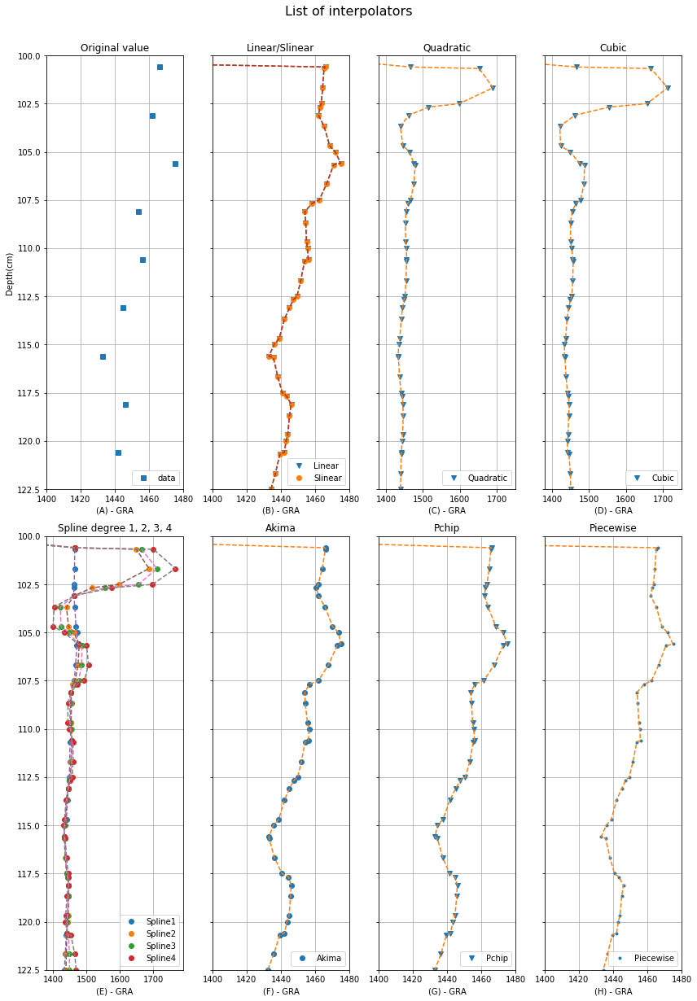

Figure 1 List of interpolators. Data example: GRA geophysical property, site U1480, hole E, Core 1H, Section 2 (range 100 cm to 122.5 cm). The depth is measured in cm according to the shipping definitions. The geophysical properties GRA, MS, RSC, PWL, NGR, MAD and RGB have specific range and reading values (column y of the figure). (A) are the points of reading the original data. (B) are the data interpolated by the Linear and Slinear interpolator. (C) are the data interpolated by the Quadratic interpolator. (D) are the data interpolated by the Cubic interpolator. (E) are the data interpolated by the Spline interpolator degree 1, 2, 3 and 4. (F) are data interpolated by the Akima interpolator. (G) are data interpolated by the Pchip interpolator. (H) are data interpolated by the Piecewise interpolator.

**Linear**

Linear interpolation or Interpolation 1-D is the process of interpolation between two points in the same dimension (SALOMON, 2006; PROYAN and KISELEV, 2010). A line is used between two neighboring samples and the appropriate point is calculated along that line according to the interval defined in the depth line (cm) as shown in the Fig. 1 - B e Fig. 2.

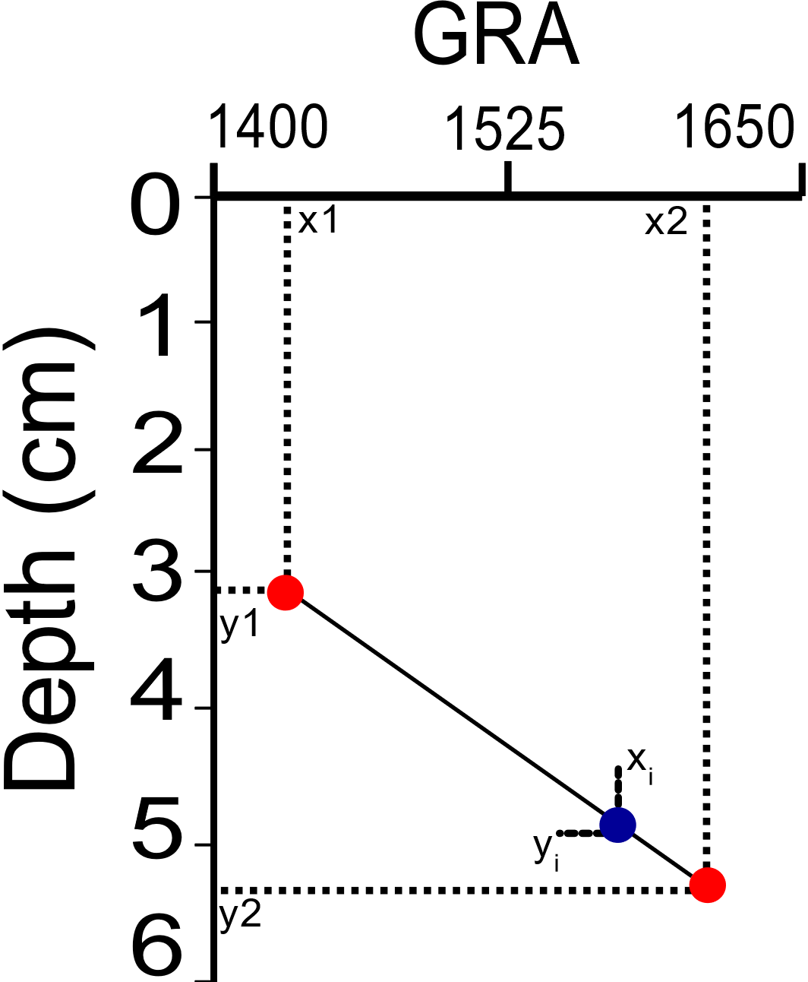

Figure 2 Value interpolation model using linear interpolator. Example for GRA geophysical property, site U1480, hole E, Core 1H, Section 2 (range 0cm to 6cm). The depth is measured in cm according to the shipping definitions. The geophysical properties GRA, MS, RSC, PWL, NGR, MAD and RGB have specific range and reading values (column y).

Column x is defined as the value of the geophysical property, in this case it is GRA, and line y is the depth value. y1, y2, x1, x2 are original values obtained by the IODP-Expedition. The equation for calculating the interpolation value xi at depth xi is defined as:

|  |  |  |
| --- | --- | --- |
|  | $x_{i}=y1+\left(x_{i}-x1\right)(\frac{y2-y1}{x2-x1})$, y1 < $x_{i}$ < y2. | (1) |

**Quadratic and Cubic**

Quadratic interpolation and cubic interpolation are performed using polynomials of degrees 2 and 3 at different points p'0, p'1, ..., p'n (Fig. 1 - C, D) each with polynomial function ${fp}_{{p'}_{n}}$ defined by (PROYAN and KISELEV, 2010; BUZZI-FERRARIS and MANENTI, 2010):

|  |  |  |
| --- | --- | --- |
|  | ${fp}_{{p'}_{n}}= a_{0}+ a_{1}x+ a_{2}x^{2}$, for degrees 2 | (2) |
|  | ${fp}_{{p'}_{n}}= a_{0}+ a_{1}x+ a_{2}x^{2}+ a_{3}x^{3}$, for degrees 3 | (3) |

Where $a_{0}$, $a_{1}$, $a_{2}$ and $a_{3}$ are the pairs of coefficients to be calculated, in this case, depth and value of the geophysical property with interpolation flow from the smallest to the largest in relation to the reading value of the geophysical property and the depth, and with quantity reading values of the geophysical property greater than two units per core and section.

The list of original points (geophysical properties) are organized in a matrix where each ready (matrix line with three point interpolation (for degrees 2) and four point interpolation (for degrees 3)) represents the calculation of the ${fp}_{{p'}_{n}}$ function resulting in a matrix of non-zero determinant and admitting a single result.

**Spline**

Spline interpolator is composed of a set of polynomial functions that are connected by certain nodes in certain sections of a curve defining that at each point of interpolation two polynomials connect and their first derivatives must have the same value as all derivatives (K- 1) must be continuous (SALOMON, 2006; LYCHE and MØRKEN, 2018). Spline acts in the processing of curves and smoothing being related to its data set (points) and its functions (formulas).

The interpolator is classified according to the combination of the type of degree (K) of the polynomials present, its complexity in the analysis of the combination of points and smoothing of the nodes or the curve in the interpolated section, with the cubic spline being the most used. In this article, combinations of the spline in the degree of the polynomial were used (K - 1, 2 ≤ K ≤ 5).

Spline degree 1 or Spline Linear consists of several linear polynomials (Sp(x)) joined in order to achieve continuity between the original points and the interpolated points. Fig. 1 - E and Fig 3 represents visual analysis in the application of the grade 1 spline and Eq. 4 describes how the operation is performed.

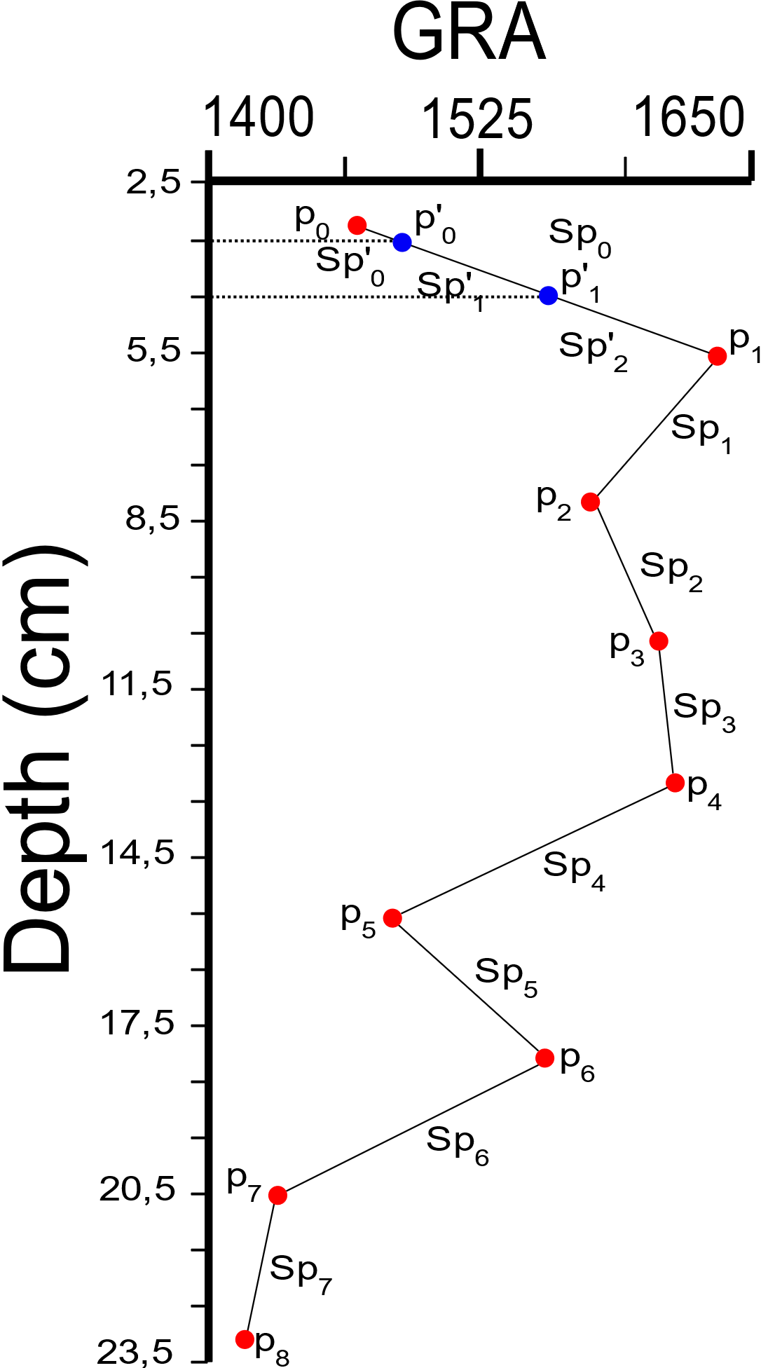

Figure 3 Value interpolation model using Spline degree 1 interpolator. Example for GRA geophysical property, site U1480, hole E, Core 1H, Section 2 (range 2.5 cm to 23.5 cm). The pi (0 to 8) points are original values of the property reading on the expedition. The p'i (0 to 1) points are values to be interpolated according to the defined depth interval setting. Spi and Sp'i are segments between the original points and points calculated according to the quantity and degree of polynomials using, resulting in the shape of the connection (line or curve).

|  |  |  |
| --- | --- | --- |
|  | Sp’(x) = | (4) |
|  |  |  |

where Sp'(x) is the segment to be calculated according to the depth value, $x$ is the geophysical property value, $m_{i}$ is the slope value of the curve calculated by the derivative, $y_{i}$ is the depth value (in cm) and $p_{i}$ is the point value (interpolated value found).

Importantly, Sp(x) is an interval between min ($x$) and max ($x$), continuous between max ($x$) and min ($x$), and min ($x$) = $p_{0}$ < $p_{1}$ < $p_{2}$... = max ($x$), such that Sp(x) is a linear polynomial at each interval between points $p_{i}$.

Splines of higher degree such as degree 2, 3 and 4 are applied at the approach level when it requires greater smoothness in calculating the curve. By the degree of the polynomial (K), it is necessary to determine the value of K-1 control points on the position of Sp'(x) resulting in an accuracy in the angle and shape of the curvature of the new segment. The Sp'(x) function for splines of higher degree follows the linear spline pattern by adjusting the quantity and degree of polynomials in each Sp(x) segment.

**Slinear**

The Slinear interpolation method acts in a similar way to the linear interpolator and spline interpolator degree 1 (Fig. 1 - B) using the same calculation bases (equations). Its main characteristic is the interpolation of values according to a pattern (within a defined range) of the starting and ending points (SALOMON, 2006). Outliers are discarded, making it impossible to continue interpolation. Slinear depends on the values being in a logical sequence of operation, their interpolation order follows the flow $x$ → $x$, where $x$ is the value of the geophysical property with an initial value in relation to the non-zero depth.

**Akima**

Akima or Sub-Spline interpolator is a method of interpolation in the form of a cubic polynomial in parts acting in a univariate manner similar to a Spline degree 3 (AKIMA, 1986; FEDOROV, 2013), according to the equation:

|  |  |  |
| --- | --- | --- |
|  | $${fp}_{{p'}_{i}}= a_{i}+ b_{i} \left(x- x_{i}\right)+ c_{i} {\left(x- x_{i}\right)}^{2}+ d_{i}(x- x_{i})³$$ | (5) |

Where $a_{i}$, $b_{i}$, $c_{i}$ and $d_{i}$ are determined through the derivative of each point $p_{i}$. $x$ is the value of geophysical property and $x_{i}$ is the value of the geophysical property to be calculated at the point ${p'}_{i}$.

The method is based on a function composed of a set of polynomials of degree 3 and applied to successive data point intervals. It acts in order to estimate the first derivative of the function at each point (respective slope of the curve) based on the analysis of up to six reference points according to Fig. 1 - F and Fig. 4. The resulting curve adapts to various types of univariate data with the presence of several original random points.

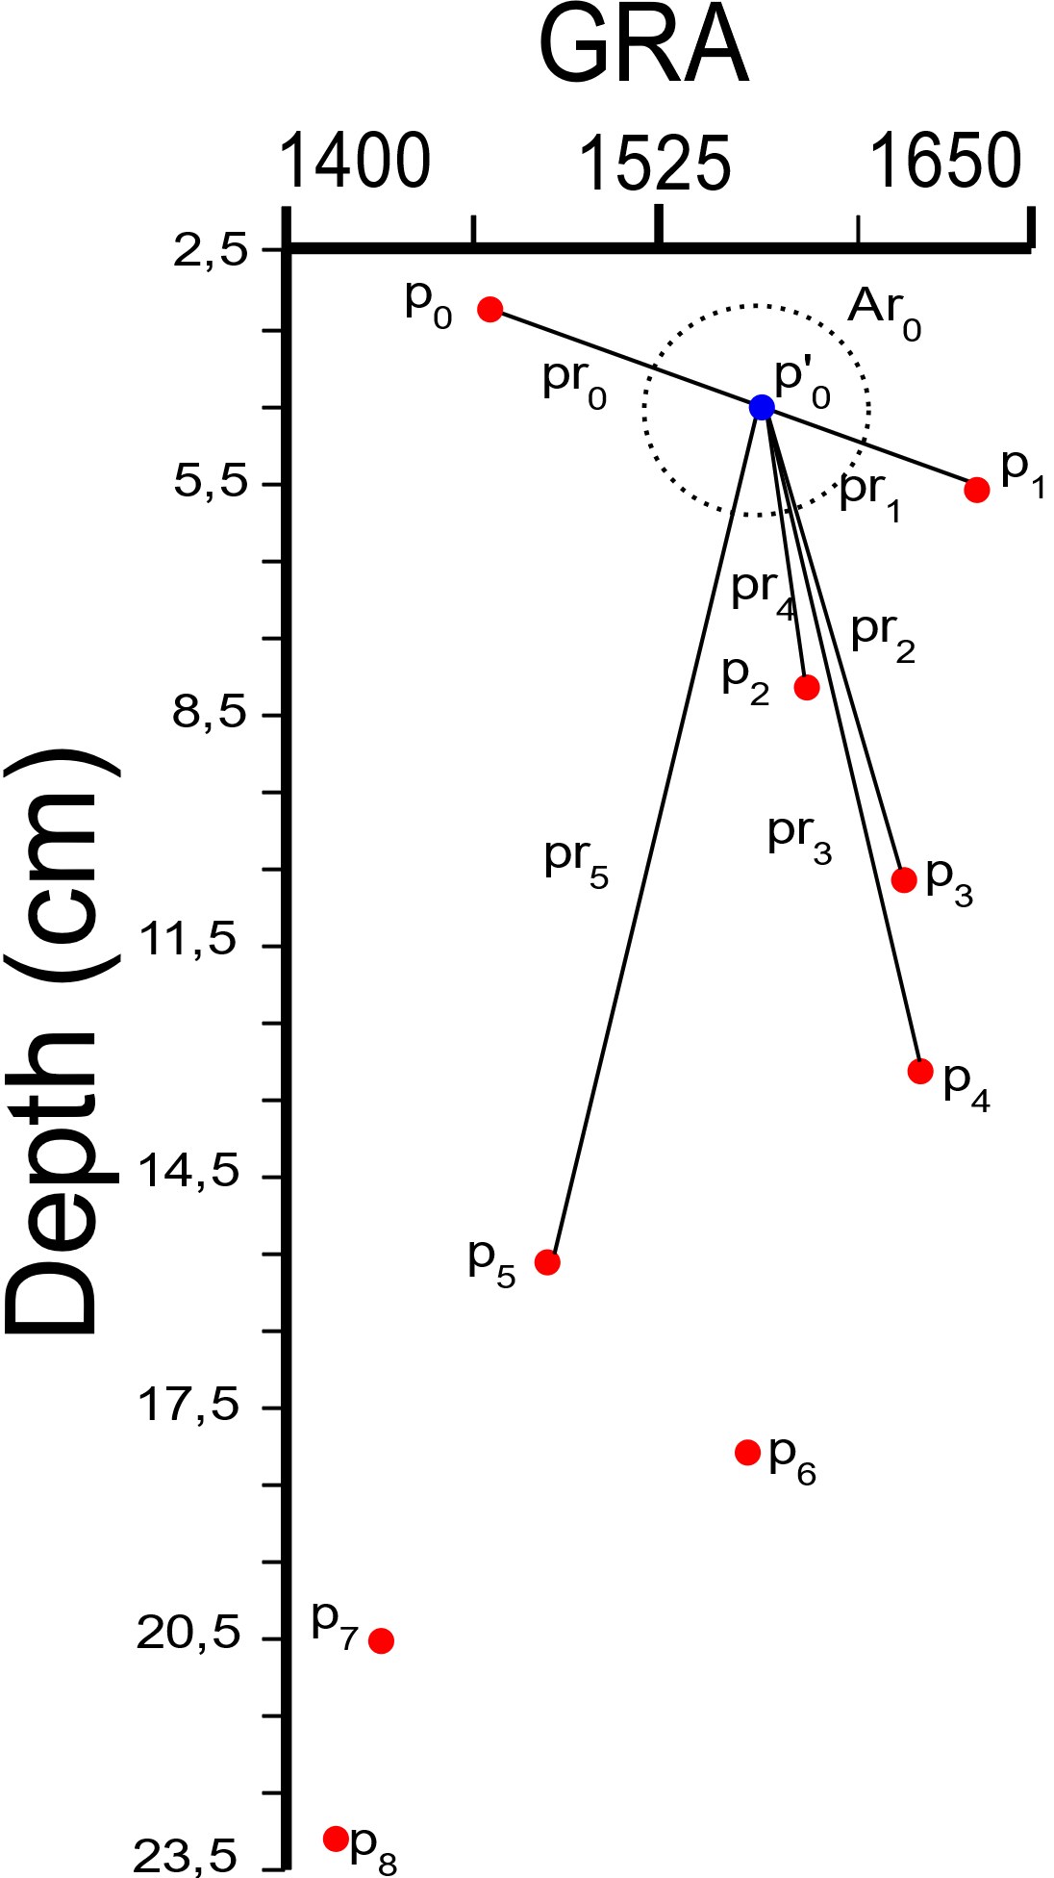

Figure 4 Value interpolation model using Akima interpolator to a point p'0 with six reference points. Example for GRA geophysical property, site U1480, hole E, Core 1H, Section 2 (range 2.5 cm to 23.5 cm). pi are points with reading values between depth and geophysical property. p’i point to be interpolated. Ar0 is the possible location area for the interpolated point. pri are the connections to the reference points pi.

Contrary to the Spline Degree 3, the Akima method does not require continuity of the second derivative, does not act in smoothing the curve, reduces the oscillation that Spline usually produces and uses the other derivatives as free parameters between the location and the reference points analyzed.

**Pchip**

Piecewise Cubic Hermite Interpolating Polynomial (Pchip) is an interpolator that uses data in the cubic Hermite format by dividing the interpolation into equal parts or subsets of cubic polynomials. Pchip has a more suitable application in relation to cubic Spline if the data has flat and steep sections preserving the geometry of the data location and the monotonicity between the points (RABBATH and CORRIVEAU, 2019; FRITSCH, 1982). Pchip identifies 4 different points and analyzes their slopes (through derivatives degree 1, 2 and 3) and the average between the connections of the points through a linear interpolator returning the value of the interpolation function as defined in the equation ${fp}_{x}$:

|  |  |  |
| --- | --- | --- |
|  | $${fp}_{x}= d_{0}+ d_{1}*x+ d_{2}* x^{2}+ d_{3}* x^{3}$$ | (6) |

Where $x$ is the point to be calculated, $d_{0}$, $d_{1}$, $d_{2}$ and $d_{3}$ are derived from the four points analyzed, respecting the value with the respective sign (negative or positive).

The main characteristics of the Pchip are in the sense that it analyzes the slope of the four points analyzed using its derivatives, respects the monotonicity between the data intervals, presents less overshoot / undershoot than the Spline interpolator and presents itself as a method to perform curve adjustments for all data points (Fig. 1 - G).

**Piecewise**

Piecewise interpolator interpolates the value between two distinct irregular points using polynomials in parts and respective derivatives of the points (FEDOROV, 2013). It uses the same equation as the Spline interpolator, the definition of the degree of the polynomial is dynamic and adapts to the degree necessary to cover all derivatives at the analyzed points (or interval).

Piecewise seeks to use an equal number of derivatives (polynomial degree) at each point in the interval. If the number of possible derivatives is different, it will use the lowest value or the value of the righter point of the segment (curve). An exception will be reported if it is not possible to calculate the derivatives of the analyzed points or the number of derivatives for interpolation results in high values making an appropriate calculation impossible (Fig. 1 - H).

**Operation flow of the interpolators**

It is important to highlight that each interpolator analyzes the original data range of the geophysical properties and performs the operation flow for interpolation according to the location characteristics between depth and number of features present by dataset in relation to the core and section. The table 1 shows the operation flow of each interpolator based on the geophysical properties used in this article.

Table 1: Operating flow of interpolators.

|  |  |
| --- | --- |
| **Interpolator** | **Operation Flow** |
| 1. Linear | $x$ ↔ $x$ |
| 2.1 Quadratic | $x$ → $x$ |
| 2.2 Cubic | $x$ → $x$ |
| 3. Spline | $x$ ↔ $x$ |
| 4. Slinear | $x$ → $x$ |
| 5. Akima | $x$ → $x$ |
| 6. PChip | $x$ ↔ $x$ |
| 7. Piecewise | $x$ → $x$ |

The operation flow described in the interpolators comprises the depth range of the hole, core and section respectively with the sequence of features of the GRA, MAD, MS, NGR, PWL, RGB and RSC geophysical properties.

The Linear interpolator being a 1-D dimension interpolator processing data between two variables (two points $p_{i}$) covers the creation of new data interpolated in the flow $x$ ↔ $x$ of greater or lesser value of $x$, where $x$ is the value of the geophysical property in relation to depth.

Quadratic, Clubic and Piecewise interpolators are interpolators that, in their design, use polynomials in the interpolation processing, requiring initial values ​​for the interpolation flow by performing the operation in the $x$ → $x$ direction where $x$ is the geophysical property value in relation to non-zero depth and reading value greater than two units per core and section.

Slinear interpolator, as already described, by the initial and final data range characteristic follows the operation flow $x$ → $x$ where $x$ is the value of the geophysical property with initial value in relation to the non-zero depth.

Spline and Pchip interpolator cover interpolation with polynomial functions in calculating the segment between the points, but the continuity between the other points will occur through the processing of a linear polynomial reaching an operation flow of the interpolation equal to the Linear Interpolator.

Akima interpolator uses a set of polynomials in parts grouped according to the distribution of the points and their connections. In addition to the characteristic, it requires reference points when designing the interpolation without making it impossible to perform the operation. The operation flow follows the logical sequence $x$ → $x$ where $x$ is the value of the geophysical property with an initial value in relation to the non-zero depth.

References

AKIMA, H., 1986. A Method of Univariate Interpolation That Has the Accuracy of a Third-Degree Polynomial. Institute for Telecommunication Sciences, National Telecommunications and Information Administration, U.S. Department of Commerce.

BUZZI-FERRARIS, G., MANENTI, F., 2010. Interpolation and Regression Models for the Chemical Engineer: Solving Numerical Problems. Chapter 1. WILEY-VCH Verlag GmbH & Co. KGaA.

FEDOROV, D. V., 2013. Introduction to Numerical Methods. Version 13.05. GNU Licence.

FRITSCH, F. N., 1982. PCHIP FINAL SPECIFICATIONS. Version 8.5. Lawrence Livermore National Laboratory, August 1982.

LYCHE, T., MØRKEN, K., 2018. Spline Methods Draft. Department of Mathematics. University of Oslo.

PROYAN, V., KISELEV, Y., 2010. Statistical Methods of Geophysical Data Processing. World Scientific Publishing Co.

RABBATH, C. A., CORRIVEAU, D., 2019. A comparison of piecewise cubic Hermite interpolating polynomials, cubic splines and piecewise linear functions for the approximation of projectile aerodynamics. Defence Technology 15 (5). https://doi.org/10.1016/j.dt.2019.07.016.

SALOMON, D., 2006. Curves and Surfaces for Computer Graphics. Chapter 2. Springer. https://doi.org/10.1007/0-387-28452-4.